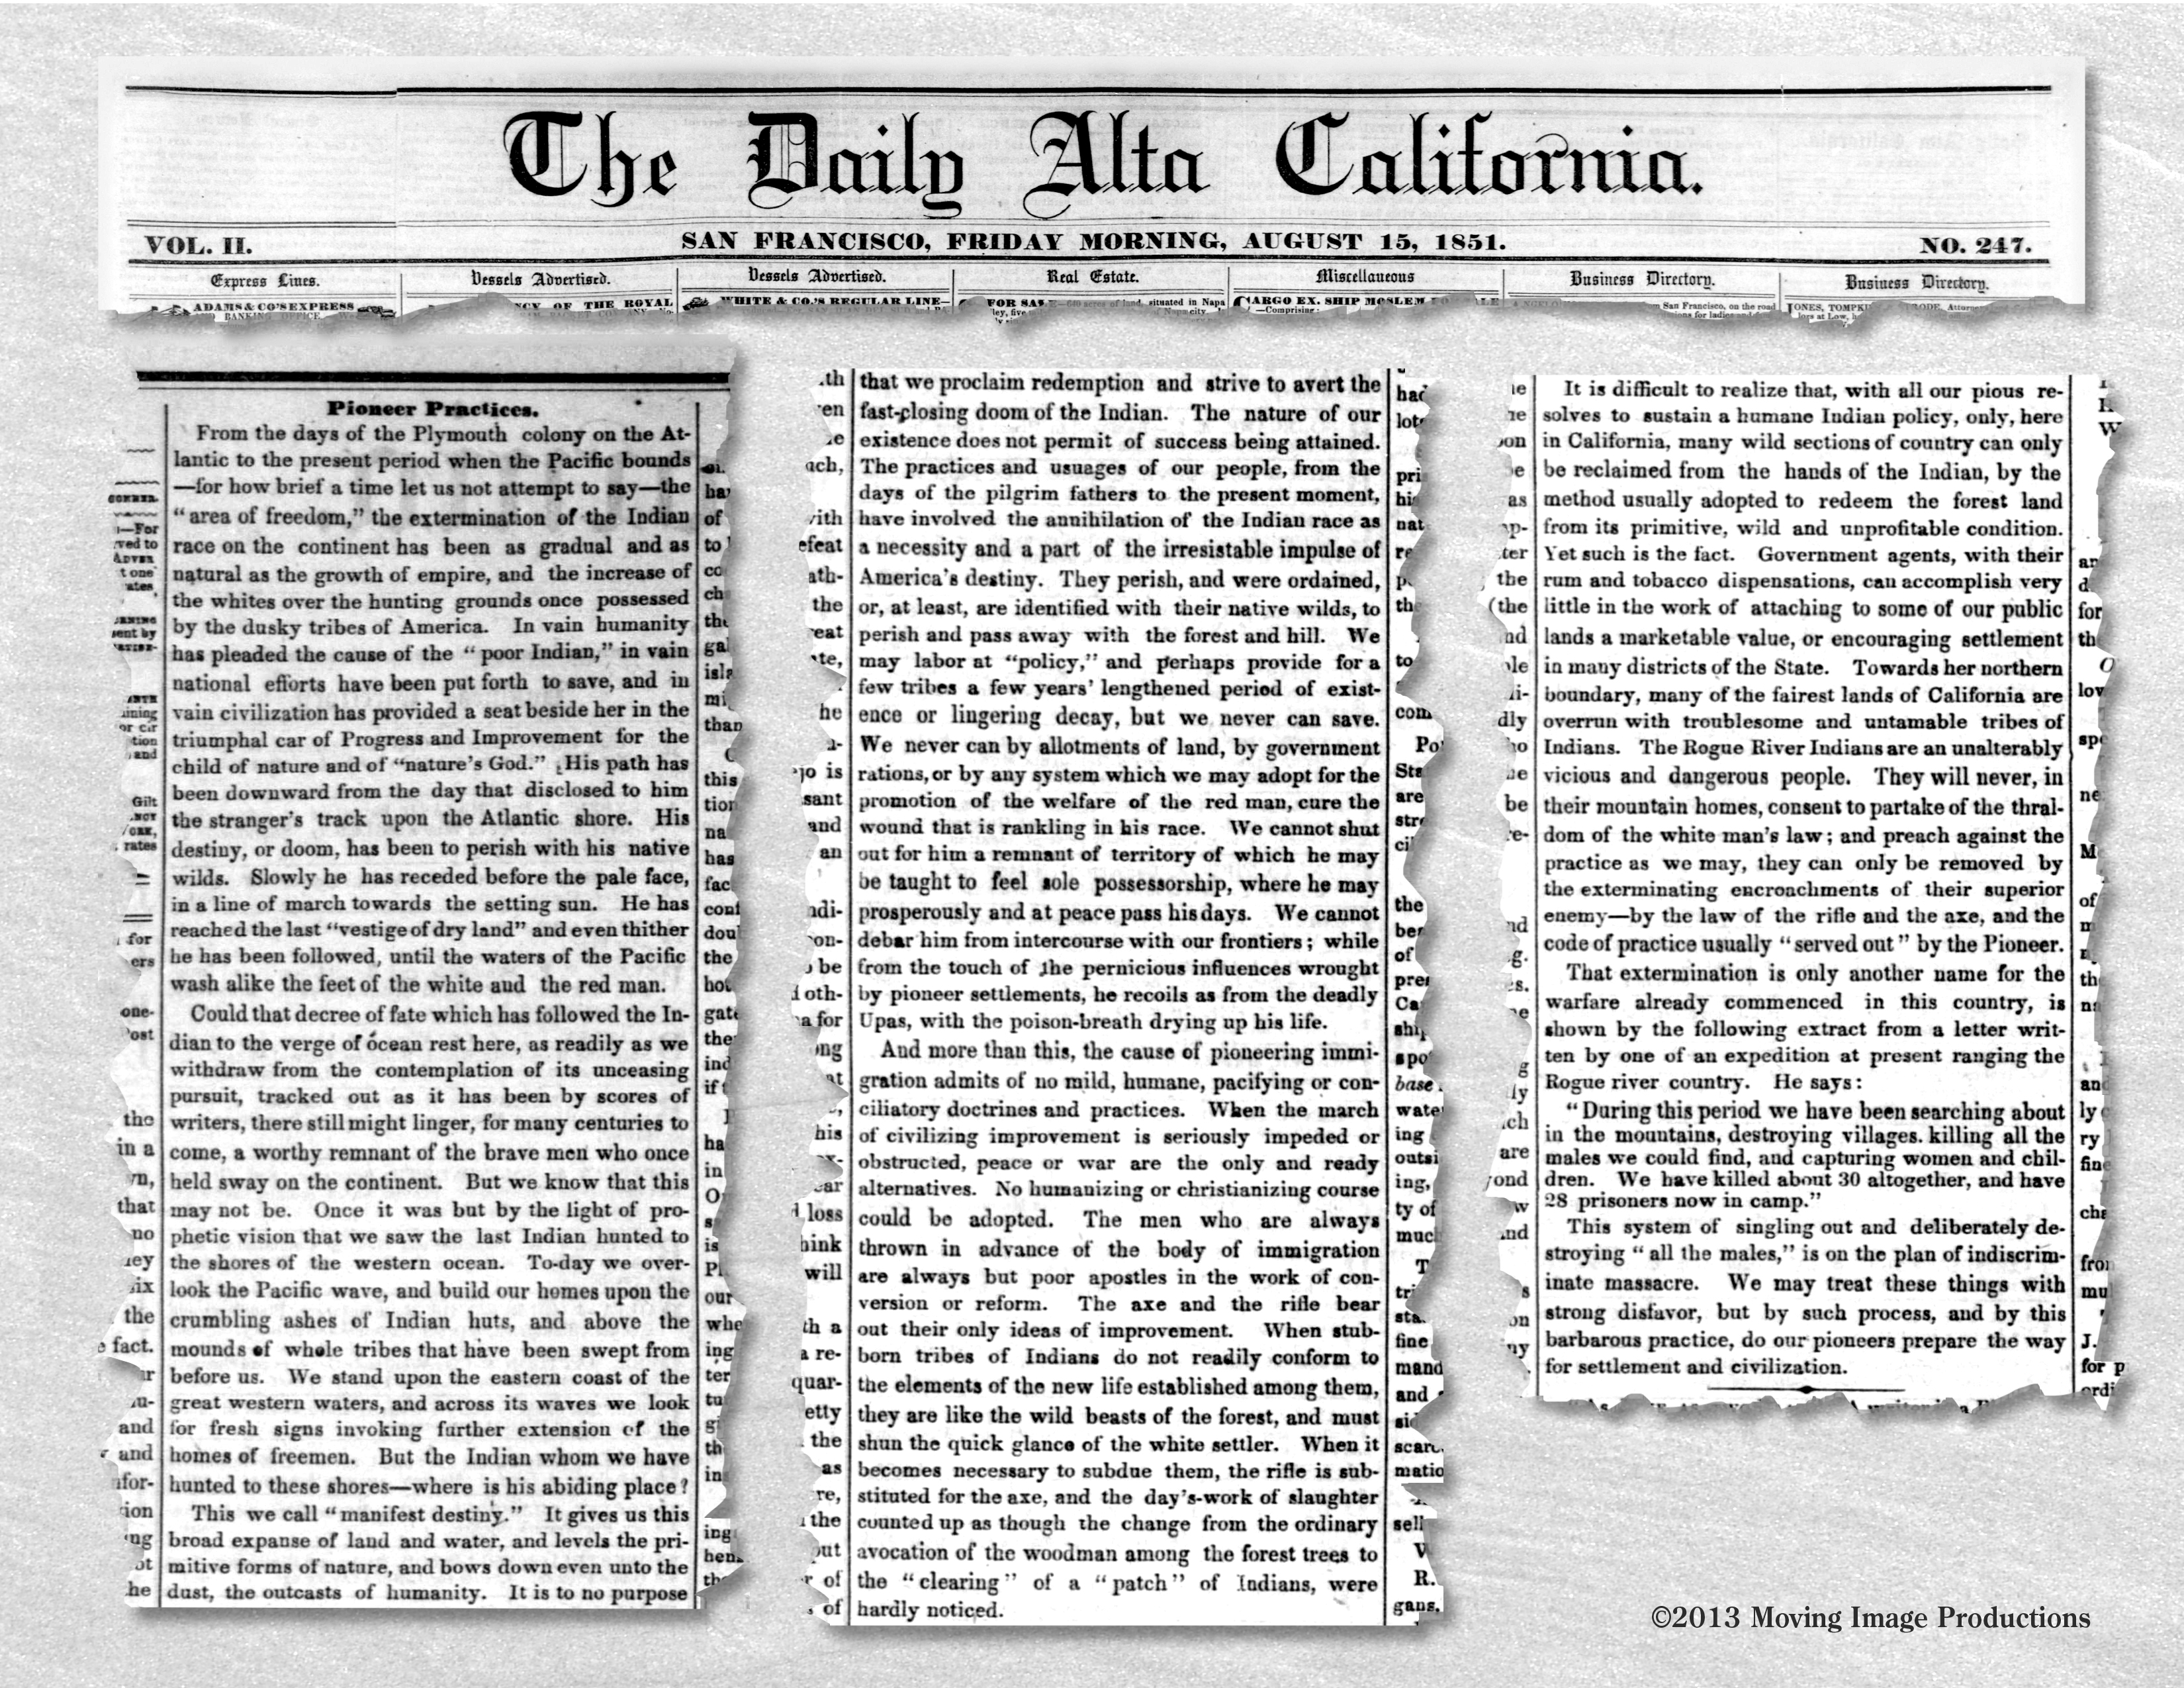

Daily Alta California – August 15, 1851

Pioneer Practices.
From the days of the Plymouth colony on the Atlantic to the present period when the Pacific bounds – for how brief a time let us not attempt to say – the "area of freedom," the extermination of the Indian race on the continent has been as gradual and as natural as the growth of empire, and the increase of the whites over the hunting grounds once possessed by the dusky tribes of America. In vain humanity has pleaded the cause of the " poor Indian,'' in vain national efforts have been put forth to save, and in vain civilization has provided a seat beside her in the triumphal car of Progress and Improvement for the child of nature and of "nature's God. His path has been downward from the day that disclosed to him the stranger's track upon the Atlantic shore. His destiny, or doom, has been to perish with his native wilds. Slowly he has receded before the pale face, in a line of march towards the setting sun. He has reached the last "vestige of dry land" and even thither he has been followed, until the waters of the Pacific wash alike the feet of the white aud the red man.
Could that decree of fate which has followed the Indian to the verge of ocean rest here, as readily as we withdraw from the contemplation of its unceasing pursuit, tracked out as it has been by scores of writers, there still might linger, for many centuries to come, a worthy remnant of the brave men who once held sway on the continent. But we kuow that this may not be. Once it was but by the light of prophetic vision that we saw the last Indian hunted to the shores of the western ocean. To-day we overlook the Pacific wave, aud build our homes upon the crumbling ashes of Indian huts, and above the mounds whole tribes that have been swept from before us. We staud upon the eastern coast of the great western waters, and across its waves we look lor fresh signs invoking further extension of the homes of freemen. But the Indian whom we have hunted to these shores – where is his abiding place? This we call "manifest destiny." It gives us this broad expanse of laud and water, and levels the primitive forms of nature, and bows down even unto the dust, tbe outcasts of humanity. It is to no purpose that we proclaim redemption and strive to avert the fast-closing doom of the Indian. The nature of our existence does not permit of success beiug attained. The practices and usuages of our people, from the days of the pilgrim fathers to the present moment, have involved the annihilation of the Indian race as a necessity and a part of the irresistable impulse of America's destiny. They perish, and were ordained, or, at least, are identified with their native wilds, to perish and pass away with the forest and hill. We may labor at "policy" and perhaps provide for a few tribes a few years' lengthened period of existence or lingering decay, but we never can save. We never can by allotments of land, by government rations, or by any system which we may adopt for the promotion of the welfare of the red man, cure the wound that is rankling in his race. We cannot shut out for him a remnant of territory of which he may be taught to feel sole possessorship, where he may prosperously and at peace pass his days. We cannot debar him from intercourse with our frontiers; while from the touch of the pernicious influences wrought by pioneer settlements, he recoils as from the deadly Upas, with the poison-breath drying up his life.
And more than this, the cause of pioneeriug immigration admits of no mild, humane, pacifying or conciliatory doctrines and practices. When the march of civilizing improvement is seriously impeded or obstructed, peace or war are the only and ready alternatives. No humanizing or christianizing course could be adopted. The men who are always thrown in advance of the body of immigration are always but poor apostles in the work of conversion or reform. The axe and the rifle bear out their only ideas of improvement. When stubborn tribes of Indians do not readily conform to the elements of the new life established amoug them, they are like the wild beasts of the forest, and must shun the quick glance of the white settler. When it becomes necessary to subdue them, the rifle is substituted for the axe. and the day's-work of slaughter counted up as though the change from the ordinary avocation of the woodman among the forest trees to the "clearing" of a "patch" of Indians, were hardly noticed.
It is difficult to realize that, with all our pious resolves to sustain a humane lndian policy, only, here in California, many wild sections of country can only be reclaimed from the hands of the Indian, by the method usually adopted to redeem the forest land from its primitive, wild and unprofitable condition. Yet such is the fact. Government agents, with their rum and tobacco dispensations, can accomplish very little in the work of attaching to some of our public lands a marketable value, or encouraging settlement in many districts of the State. Towards her northern boundary, many of the fairest lands of California are overrun with troublesome and untamable tribes of Indians. The Rogue River Indians are an unalterably vicious and dangerous people. They will never, in their mountain homes, consent to partake of the thraldom of the white man's law; and preach against the practice as we may, they can only be removed by the exterminating encroachments of their superior enemy – by the law of the ritle and the axe, and the code of practice usually "served out" by the Pioneer.
That extermination is only another name for the warfare already commenced in this country, is shown by the following extract from a letter written by one of an expedition at present ranging the Rogue river country. He says:
"During this period we have been searching about in the mountains, destroying villages, killing all the males we could find, aud capturing women and children. We have killed about 30 altogether, aud have 28 prisoners now in camp."
This system of singling out aud deliberately destroying "all the males," is on the plan of indiscriminate massacre. We may treat these things with strong disfavor, but by such process, and by this barbarous practice, do our pioneers prepare the way for settlement and civilization.

